# 1. Preface

The **Men's Hair Salon Management System** project represents the culmination of my academic journey in the field of Computer Applications. This project is driven by the vision of modernizing salon management through the integration of technology, thereby enhancing operational efficiency and customer satisfaction in the grooming industry.

Throughout the development of this system, I have had the opportunity to explore various aspects of software development, including requirements gathering, system design, programming, and testing. The experience has deepened my understanding of how technology can solve real-world problems, particularly in small to medium-sized businesses that often struggle with manual management processes.

The motivation behind this project stemmed from my observation of the challenges faced by hair salon owners in managing their operations effectively. Through interviews and research, I identified key pain points, such as appointment scheduling conflicts, staff management issues, and inventory tracking difficulties. It became clear that a comprehensive management system could address these challenges, leading to improved efficiency and a better customer experience.

In this report, I have detailed the methodologies used in the development of the system, along with the design choices made to ensure a user-friendly interface and robust functionality. It is my hope that this project not only demonstrates my technical skills but also contributes to the field of salon management by providing a viable solution for salon owners looking to modernize their operations.

I would like to express my gratitude to my supervisor, **Prof.NileshParghi**for their guidance and support throughout this project. I also appreciate the insights provided by salon owners and staff, which were instrumental in shaping the system's functionalities. Their feedback has ensured that the final product meets the practical needs of the salon industry.

This project is dedicated to all aspiring entrepreneurs in the salon industry who strive to improve their operations and deliver exceptional services to their clients. May this work inspire further innovations and advancements in the field of salon management.

# 2. Acknowledgment

We would like to take this opportunity to express our deep gratitude to all those who supported us in the completion of this project.

First and foremost, we would like to thank **Prof. Nilesh Parghi**, our project guide, for their constant guidance, encouragement, and valuable suggestions during the development of the "Men’s Hair Salon Management System." Their knowledge and insights were invaluable in shaping this project.

We are also grateful to **Prof. Vipul Baldha** and the faculty of **Kamani Science and Prataprai Arts College** for providing the necessary resources and an excellent environment to work on this project.

Our heartfelt thanks go to our families and friends for their unwavering support and encouragement throughout the project. Without their patience and understanding, the completion of this project would not have been possible.

Lastly, we extend our gratitude to everyone who contributed, directly or indirectly, to the successful realization of this project.

***THANKS TO ALL!!***

# 3. Abstract

The **Men's Hair Salon Management System** is designed to address the inefficiencies in traditional salon management processes, including manual booking, appointment scheduling, staff management, and inventory tracking. The system provides a comprehensive digital solution to automate these tasks, improving the overall customer experience and reducing administrative burdens for the salon management.

This project utilizes a client-server architecture built with **HTML, CSS, JavaScript, PHP, and MySQL**, offering a responsive and user-friendly interface for both salon staff and customers. The system is equipped with features such as customer profile management, appointment scheduling, staff shift allocation, and inventory tracking. It also includes a secure payment module for handling customer payments and generating invoices.

The development of this system is motivated by the growing demand for streamlined and efficient management in small- to medium-sized salons. By implementing the **Men's Hair Salon Management System**, salon owners can ensure better resource management, optimize staff productivity, and provide customers with a hassle-free salon experience.

Key features of the system include:

* Appointment booking and management
* Inventory control for salon products
* Payment processing and report generation

The system’s effectiveness has been validated through rigorous testing and demonstrates clear improvements in salon operation management. This report details the design, development, and testing processes, providing a complete overview of how the system meets its objectives.

# 4. Introduction

The management of a men's hair salon involves several day-to-day activities, such as booking customer appointments , managing inventory , and processing payments. Traditionally, these tasks are often handled manually, which can be time-consuming and prone to errors. With the increasing demand for grooming services, many salons face the challenge of keeping up with customer expectations while managing their operations efficiently.

To address these challenges, the **Men's Hair Salon Management System** has been developed as a software solution to streamline and automate the essential functions of a salon. The system provides salon managers with a comprehensive tool to customer appointments , customer memberships like ( Royal , Classic & Standard ), managing services like ( Haircut , Beardtrim , Skin Treatment & Spa Services ) , managing inventory products like ( Haircare , Beardcare & Skincare Products ) , and processing payments , and financial transactions all in one platform. It allows for real-time booking and customer management, ensuring that salon operations run smoothly and effectively.

This project aims to create a user-friendly and responsive platform, developed using **PHP and MySQL**, with a focus on automating the critical functions of a salon. The system will reduce manual effort, eliminate human errors, and improve the overall customer experience. Additionally, by integrating features such as report generation and secure payments, the system enables salon owners to keep track of their business performance with ease.

This software will enhance salon efficiency, saving time and boosting customer satisfaction by simplifying appointment bookings and payments..

# 5. Timeline Chart

Below is the timeline for developing the Men's Hair Salon Management System:

|  |  |
| --- | --- |
| Preliminary | : 10 Days |
| System Analysis | : 10 Days |
| System Design | : 15 Days |
| Coding | : 25 Days |
| Testing | : 3 Days |
| Implementation | : 5 Days |
| Maintanance | : 15 Days |

# 6. Project Profile

|  |  |
| --- | --- |
| * **Project Name** | : Men's Hair Salon Management System |
| * **Brand Name** | : ClassyCut |
| * **Developed By** | : HariyaniAkshay A.  Sapra Adesh C.  Dodiya Prince M. |
| * **Front-End Tools** | : HTML, CSS, JavaScript |
| * **Back-End Tools** | : PHP, MySQL |
| * **Operating System** | : Windows 10 |
| * **Completion Time** | : 2.5 Months |
| * **Guided By :** | : Prof. NileshParghi |
| * **Submitted by** | : Saurashtra University, Rajkot |

# 7. SDLC( Software Development Life Cycle)

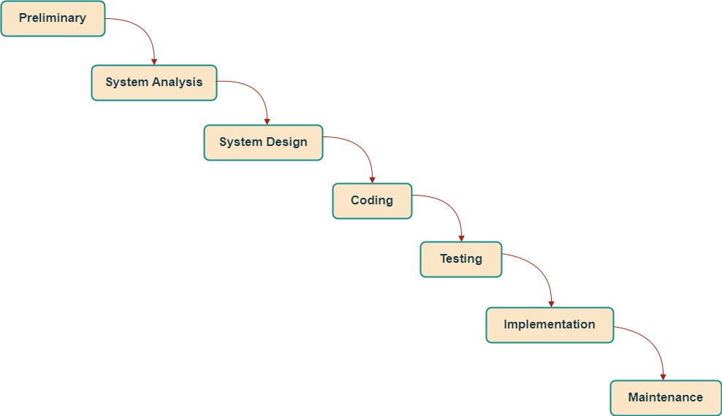

* **HARDWARE REQUIREMENTS**

- 2 GB RAM or more  
- Dual-core processor or higher  
- 500 MB of hard drive space  
- Printer (optional for reports)

* **SOFTWARE REQUIREMENTS**

- Operating System: Windows 10  
- Front-end: HTML, CSS, JavaScript  
- Back-end: PHP, MySQL  
- Browser: Google Chrome or Firefox  
- Text Editor: Sublime Text or Visual Studio Code

* **REQUIREMENTS GATHERING**

**1**.**What services does your salon offer?**

* Haircuts, Shaves, Hair Coloring, Hair Grooming, and other grooming services.

**2.What are your operating hours?**

* Monday to Friday: 9 AM to 8 PM
* Sunday: 10 AM to 5 PM
* Closed on Saturdays

**3.Do you offer appointment bookings?**

* Yes, clients can book appointments online, over the phone, or in person.

**4.What kind of customer data do you want to collect?**

* Names, Contact Information, Service History, and Customer Feedback.

**5.What is your contact number or email ID?**

* Email: classycut007@gmail.com
* Phone: 7575852866, 9724564357

**6.Do you need an inventory management system? If yes, what products or supplies do you want to manage?**

* Yes, we need to manage stock levels for hair products, tools, and other supplies.

**7.How do you want to handle payments?**

* We accept cash, credit cards / Debit cards, and mobile payments.

**8.What security measures are important for you?**

* Data encryption, user authentication, and regular backups.

**9.Do you need multi-language support?**

* Yes, Hindi and English.

**10.Do you need a customer feedback or review system?**

* Yes, collecting customer feedback after services and reviews is important.

**11.How do you currently schedule appointments?**

* Currently, appointments are primarily scheduled over the phone or in person.

**12.Is the system mobile-friendly?**

* Yes, the system is designed with a responsive layout for both desktop and mobile devices.

**13.Do you offer membership plans?**

* Yes, we offer Royal, Classic, and Standard memberships with different pricing and benefits.

**14.How do you want to manage membership renewals?**

* Memberships should automatically renew monthly or yearly, with the option for users to manage renewals online.

**15. Do you offer any exclusive events or services for members?**

* Yes, we plan to provide exclusive access to member-only events, promotions, and premium services.

# 8. PAGE STRUCTURE

**ADMIN PAGE**

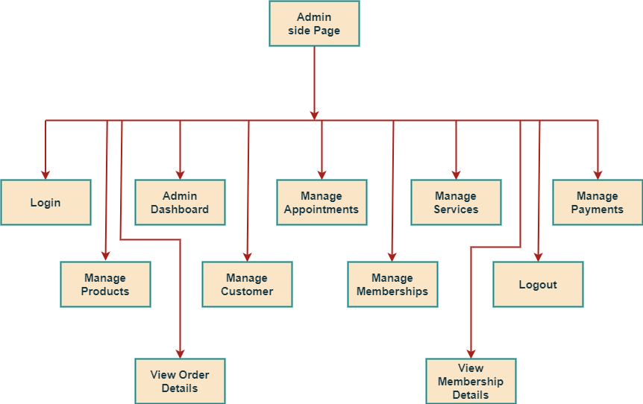

**USER PAGE**

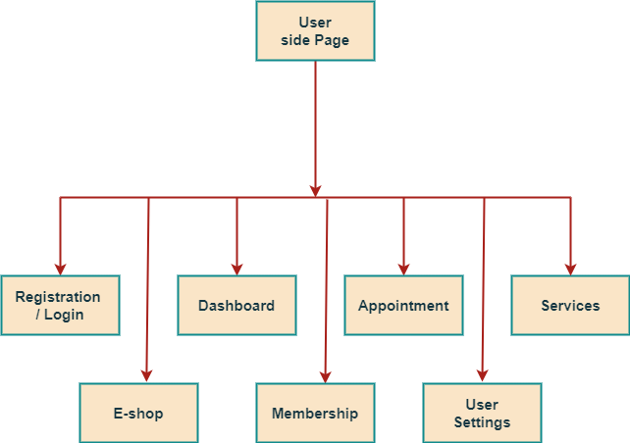

# 9. Requirement Specification

The system will have two types of users:  
  
**Admin**: Manage appointments, services, staff schedules, and product inventory. Generate reports on monthly sales, staff performance, and customer feedback.  
  
**Customer**: Book appointments, view services, and give feedback after their service.

# 10. Problem Definition

Salons often face issues like manual booking errors, customer dissatisfaction due to untracked services, and inventory mismanagement. The ClassyCut Men's Hair Salon Management System automates processes to prevent double bookings, ensure timely restocking, and collect customer feedback, addressing these common problems.

# 11. Project Planning & Scheduling

The project is planned as follows:  
1. Requirement Gathering  
2. Design  
3. Development  
4. Testing  
5. Implementation  
6. Maintenance  
Each stage focuses on improving the functionality and user experience.

# 12. System Analysis

System analysis identified pain points like appointment management, staff scheduling, and inventory control. The system was designed to solve these issues using a simple interface for both staff and customers.

# 13. Feasibility Study

**Technical Feasibility**: The system is built using technologies that are widely supported and easy to maintain.  
  
**Operational Feasibility**: Staff and customers can easily adapt to the system with minimal training.  
  
**Economic Feasibility**: The system offers a low-cost solution compared to traditional management software.

# 14. Data Dictionary

Below are examples of the tables used in the Men's Hair Salon Management System:

Table : user_reg

* This is user registration and login table .

|  |  |  |  |  |
| --- | --- | --- | --- | --- |
| NO. | NAME | TYPE | SIZE | ATTRIBUTE |
| 1 | **id Primary** | Int | 100 | **PRIMARY KEY** |
| 2 | **name** | Varchar | 100 | **-** |
| 3 | **email** | Varchar | 100 | **-** |
| 4 | **username** | Varchar | 100 | **-** |
| 5 | **password** | Varchar | 8 | **-** |
| 6 | **profile_img** | Varchar | 255 | **-** |

|  |  |  |  |  |
| --- | --- | --- | --- | --- |
| NO. | NAME | TYPE | SIZE | ATTRIBUTE |
| 1 | **admin_id Primary** | Int | 100 | **PRIMARY KEY** |
| 2 | **admin_username** | Varchar | 100 | **-** |
| 3 | **admin_password** | Varchar | 100 | **-** |
| 4 | **admin_email** | Varchar | 100 | **-** |

Table : admin

* This is admin login table .

Table : appointments

* This is appointments table .

|  |  |  |  |  |
| --- | --- | --- | --- | --- |
| NO. | NAME | TYPE | SIZE | ATTRIBUTE |
| 1 | **a_id Primary** | Int | 11 | **PRIMARY KEY** |
| 2 | **a_name** | Varchar | 50 | **-** |
| 3 | **a_email** | Varchar | 50 | **-** |
| 4 | **a_no** | Int | 10 | **-** |
| 5 | **a_date** | Date | - | **-** |
| 6 | **a_time** | Time | - | **-** |
| 7 | **a_category** | Varchar | 50 | **-** |
| 8 | **a_type** | Varchar | 50 | **-** |
| 9 | **a_status** | Varchar | 100 | **-** |

Table : appointments_history

|  |  |  |  |  |
| --- | --- | --- | --- | --- |
| NO. | NAME | TYPE | SIZE | ATTRIBUTE |
| 1 | **ah_id Primary** | Int | 11 | **PRIMARY KEY** |
|  | **a_id Index** | Int | 11 | **FOREIGN KEY** |
| 2 | **ah_name** | Varchar | 50 | **-** |
| 3 | **ah_email** | Varchar | 50 | **-** |
| 4 | **ah_no** | Int | 10 | **-** |
| 5 | **ah_date** | Date | - | **-** |
| 6 | **ah_time** | Time | - | **-** |
| 7 | **ah_category** | Varchar | 50 | **-** |
| 8 | **ah_type** | Varchar | 50 | **-** |
| 9 | **ah_status** | Varchar | 100 | **-** |

* This is appointments history table .

Services Tables :

* This is service tables for the hair , beard , skin and spa services .

hair_service :

|  |  |  |  |  |
| --- | --- | --- | --- | --- |
| NO. | NAME | TYPE | SIZE | ATTRIBUTE |
| 1 | **hair_id Primary** | Int | 11 | **PRIMARY KEY** |
| 2 | **hair_category** | Varchar | 50 | **-** |
| 3 | **hair_service** | Varchar | 50 | **-** |
| 4 | **hair_price** | Int | 50 | **-** |

beard_service :

|  |  |  |  |  |
| --- | --- | --- | --- | --- |
| NO. | NAME | TYPE | SIZE | ATTRIBUTE |
| 1 | **beard_id Primary** | Int | 11 | **PRIMARY KEY** |
| 2 | **beard_service** | Varchar | 50 | **-** |
| 3 | **beard_price** | Varchar | 50 | **-** |

skin_service :

|  |  |  |  |  |
| --- | --- | --- | --- | --- |
| NO. | NAME | TYPE | SIZE | ATTRIBUTE |
| 1 | **skin_id Primary** | Int | 11 | **PRIMARY KEY** |
| 2 | **skin_service** | Varchar | 50 | **-** |
| 3 | **skin_price** | Varchar | 50 | **-** |

|  |  |  |  |  |
| --- | --- | --- | --- | --- |
| NO. | NAME | TYPE | SIZE | ATTRIBUTE |
| 1 | **spa_id Primary** | Int | 11 | **PRIMARY KEY** |
| 2 | **spa_category** | Varchar | 50 | **-** |
| 3 | **spa_service** | Varchar | 50 | **-** |
| 4 | **spa_price** | Int | 50 | **-** |

spa_service:

Membership Tables :

* This is membership tables for the royal,classic and standard membership.

royal_membership :

|  |  |  |  |  |
| --- | --- | --- | --- | --- |
| NO. | NAME | TYPE | SIZE | ATTRIBUTE |
| 1 | **royal_id Primary** | Int | 11 | **PRIMARY KEY** |
| 2 | **royal_plan** | Varchar | 50 | **-** |
| 3 | **royal_desc** | Varchar | 50 | **-** |
| 4 | **royal_price** | Int | 50 | **-** |

classic_membership :

|  |  |  |  |  |
| --- | --- | --- | --- | --- |
| NO. | NAME | TYPE | SIZE | ATTRIBUTE |
| 1 | **classic_id Primary** | Int | 11 | **PRIMARY KEY** |
| 2 | **classic_plan** | Varchar | 50 | **-** |
| 3 | **classic_desc** | Varchar | 50 | **-** |
| 4 | **classic_price** | Int | 50 | **-** |

standard_membership :

|  |  |  |  |  |
| --- | --- | --- | --- | --- |
| NO. | NAME | TYPE | SIZE | ATTRIBUTE |
| 1 | **standard_id Primary** | Int | 11 | **PRIMARY KEY** |
| 2 | **standard_plan** | Varchar | 50 | **-** |
| 3 | **standard_desc** | Varchar | 50 | **-** |
| 4 | **standard_price** | Int | 50 | **-** |

Tables : membership_payments

|  |  |  |  |  |
| --- | --- | --- | --- | --- |
| **NO.** | **NAME** | **TYPE** | **SIZE** | **ATTRIBUTE** |
| **1** | **m_id Primary** | Int | 10 | **PRIMARYKEY** |
| **2** | **id Index** | Int | 10 | **FOREIGNKEY** |
| **3** | **membership_type** | Varchar | 50 | **-** |
| **4** | **price** | Varchar | 50 | **-** |
| **5** | **card_name** | Int | 10 | **-** |
| **6** | **phone_number** | Varchar | 50 | **-** |
| **7** | **payment_date** | Int | 10 | **-** |

* This is membership payments table .

Table : products

* This is product table .

|  |  |  |  |  |
| --- | --- | --- | --- | --- |
| NO. | NAME | TYPE | SIZE | ATTRIBUTE |
| 1 | **p_id Primary** | Int | 100 | **PRIMARY KEY** |
| 2 | **p_name** | Varchar | 255 | **-** |
| 3 | **p_desc** | Varchar | 255 | **-** |
| 4 | **p_price** | Int | 100 | **-** |
| 5 | **p_size** | Varchar | 100 | **-** |
| 6 | **p_overview** | Varchar | 500 | **-** |
| 7 | **p_f1** | Varchar | 100 | **-** |
| 8 | **p_f2** | Varchar | 100 | **-** |
| 9 | **p_ingred** | Varchar | 100 | **-** |
| 10 | **p_img** | Varchar | 255 | **-** |
| 11 | **p_quantity** | Int | 50 | **-** |

Table : products_cart

* This is products cart table .

|  |  |  |  |  |
| --- | --- | --- | --- | --- |
| NO. | NAME | TYPE | SIZE | ATTRIBUTE |
| 1 | **c_id Primary** | Int | 11 | **PRIMARY KEY** |
| 2 | **id Index** | Int | 11 | **FOREIGN KEY** |
| 3 | **p_id Index** | Int | 11 | **FOREIGN KEY** |
| 4 | **c_img** | Varchar | 100 | **-** |
| 5 | **c_name** | Varchar | 50 | **-** |
| 6 | **c_price** | Int | 11 | **-** |
| 7 | **c_size** | Varchar | 50 | **-** |
| 8 | **c_quantity** | Int | 11 | **-** |
| 9 | **c_total** | Int | 11 | **-** |
| 10 | **c_grand_total** | Int | 11 | **-** |

Table : products_sale

* This is products sale table .

|  |  |  |  |  |
| --- | --- | --- | --- | --- |
| NO. | NAME | TYPE | SIZE | ATTRIBUTE |
| 1 | **s_id Primary** | Int | 10 | **PRIMARY KEY** |
| 2 | **id Index** | Int | 10 | **FOREIGN KEY** |
| 3 | **s_img** | Varchar | 50 | **-** |
| 4 | **s_name** | Varchar | 50 | **-** |
| 5 | **s_price** | Int | 10 | **-** |
| 6 | **s_size** | Varchar | 50 | **-** |
| 7 | **s_quantity** | Int | 10 | **-** |
| 8 | **s_total** | Int | 10 | **-** |
| 9 | **s_grand_total** | Int | 10 | **-** |
| 10 | **s_date** | Date | - | **-** |
| 11 | **s_status** | Varchar | 100 | **-** |
| 12 | **s_time** | Time | 6 | **-** |

|  |  |  |  |  |
| --- | --- | --- | --- | --- |
| NO. | NAME | TYPE | SIZE | ATTRIBUTE |
| 1 | **pay_id Primary** | Int | 11 | **PRIMARY KEY** |
| 2 | **id Index** | Int | 11 | **FOREIGN KEY** |
| 3 | **s_id Index** | Int | 11 | **FOREIGN KEY** |
| 4 | **p_name** | Varchar | 50 | **-** |
| 5 | **p_phno** | Int | 10 | **-** |
| 6 | **p_address** | Varchar | 500 | **-** |
| 7 | **p_city** | Varchar | 100 | **-** |
| 8 | **p_state** | Varchar | 100 | **-** |
| 9 | **p_pincode** | Int | 6 | **-** |
| 10 | **p_method** | Varchar | 50 | **-** |
| 11 | **p_date** | Date | - | **-** |
| 12 | **p_time** | Time | - | **-** |
| 13 | **p_status** | Varchar | 100 |  |

Table : payments

* This is products payments table .

Table : wallet_transaction

* This is wallet or transaction table .

|  |  |  |  |  |
| --- | --- | --- | --- | --- |
| NO. | NAME | TYPE | SIZE | ATTRIBUTE |
| 1 | **id Primary** | Int | 11 | **PRIMARY KEY** |
| 2 | **user_id Index** | Int | 11 | **FOREIGN KEY** |
| 3 | **amount** | decimal | (10,2) | **-** |
| 4 | **date** | timestamp | - | **-** |
| 5 | **product_id Index** | Int | 11 | **FOREIGN KEY** |
| 6 | **sale_id Index** | Int | 11 | **FOREIGN KEY** |

# 15. Data Flow Diagram

The DFD gives brief idea on how the designed system is working. It alsosuggests to us the type of users who using this system and the process involved inthesystem.

Representdataflow

RepresentaEntity

Represent adata table

Representaprocessing

# Context LEVEL Data Flow Diagram

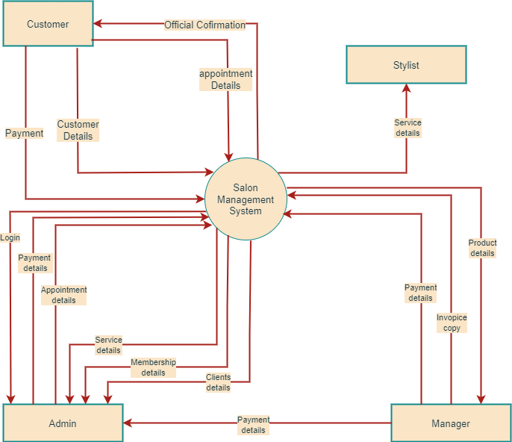

# First-Level Data Flow Diagram

`

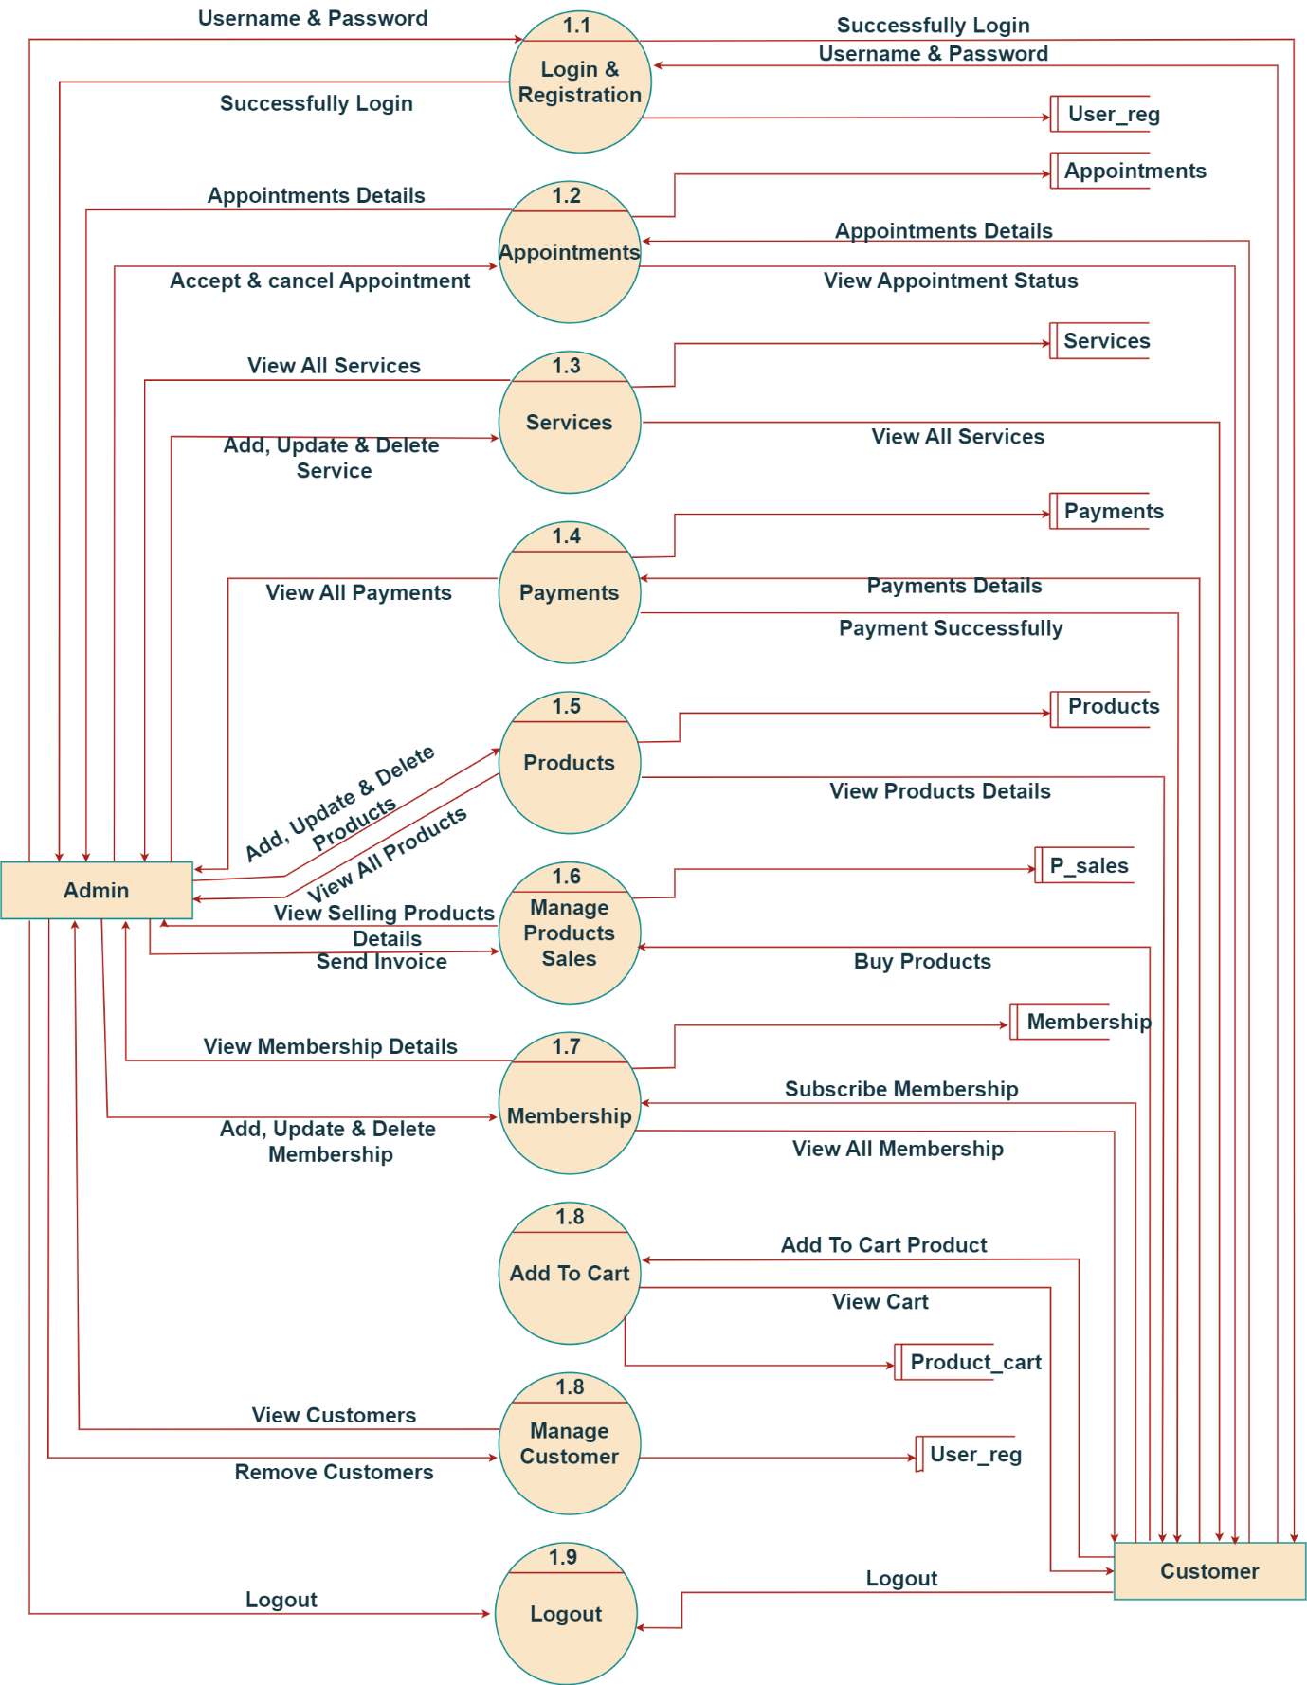

# 16. ER Diagram

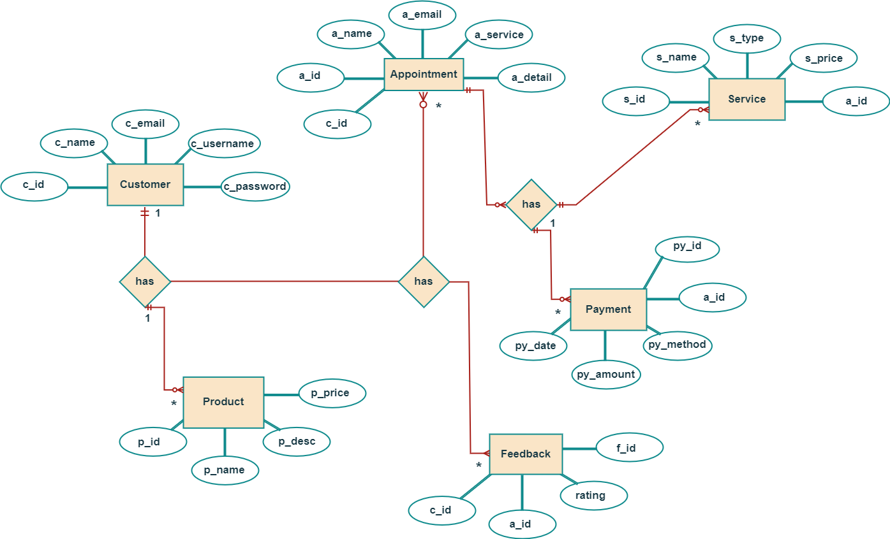

# 17. Use Case Diagram

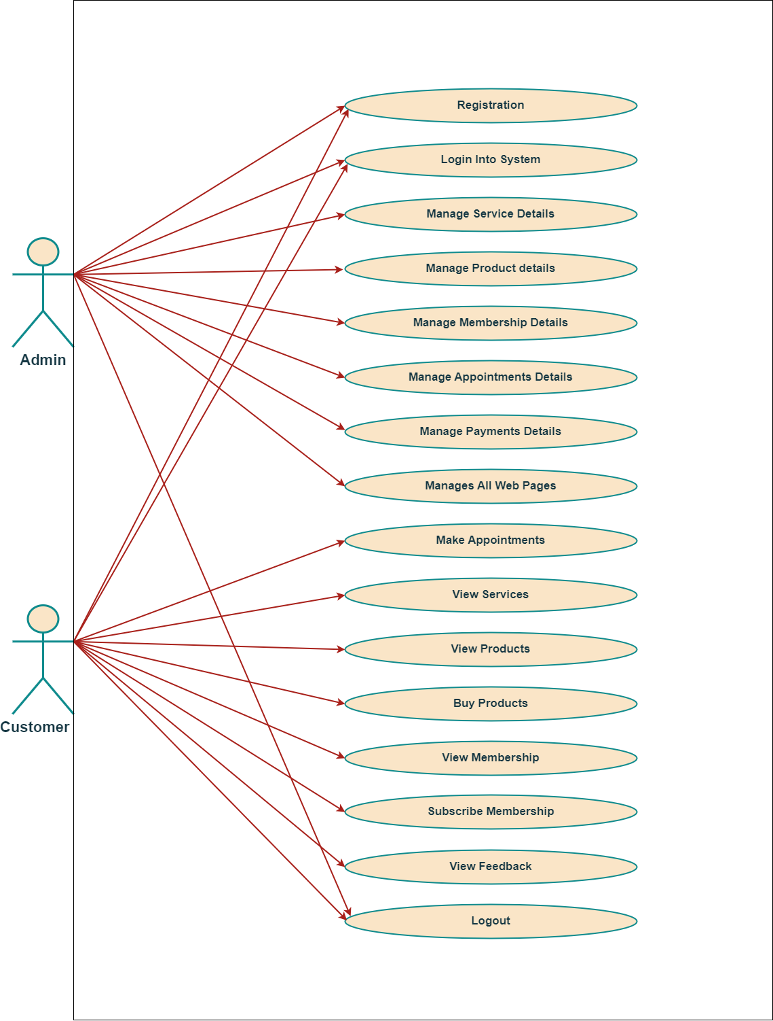

**USE CASE DIAGRAM FOR MEN’S HAIR SALON MANAGEMENT SYSTEM**

# 18. ADMIN Activity Diagram

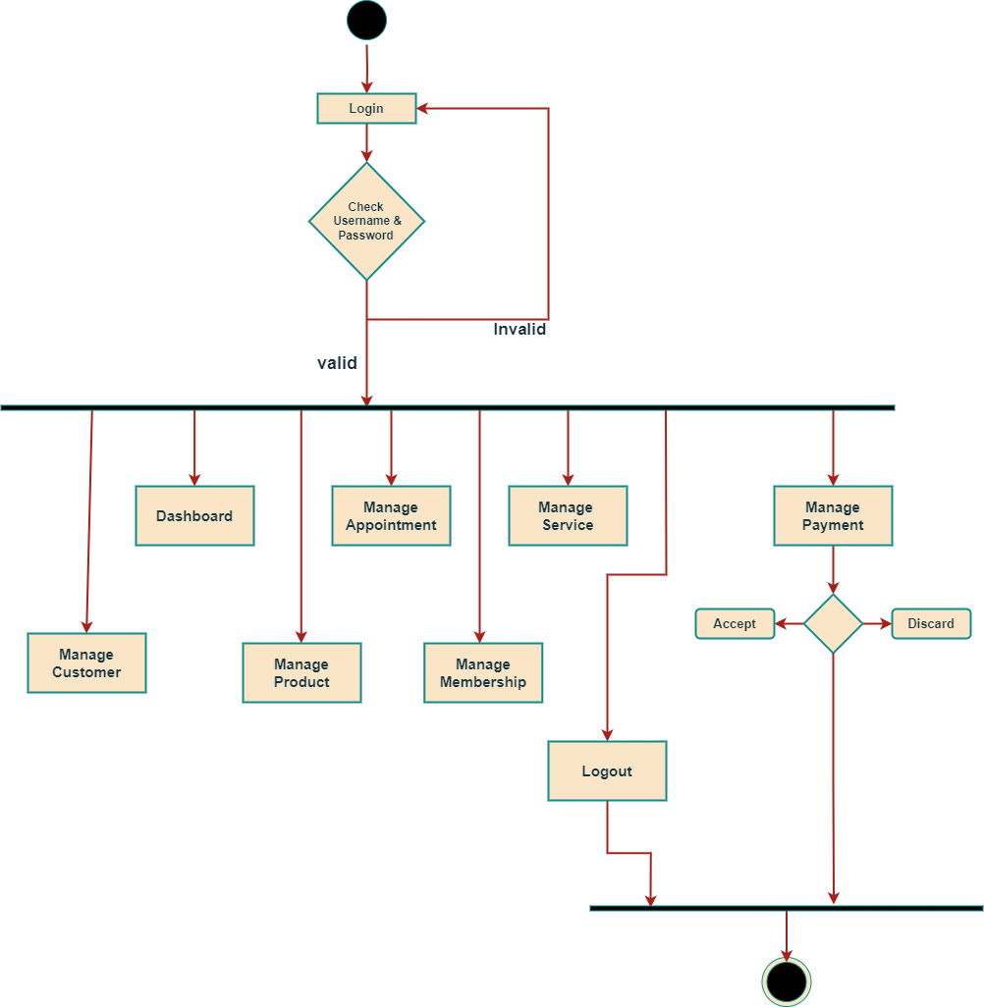

# USER Activity Diagram

# 19. ADMIN SEQUENCE Diagram

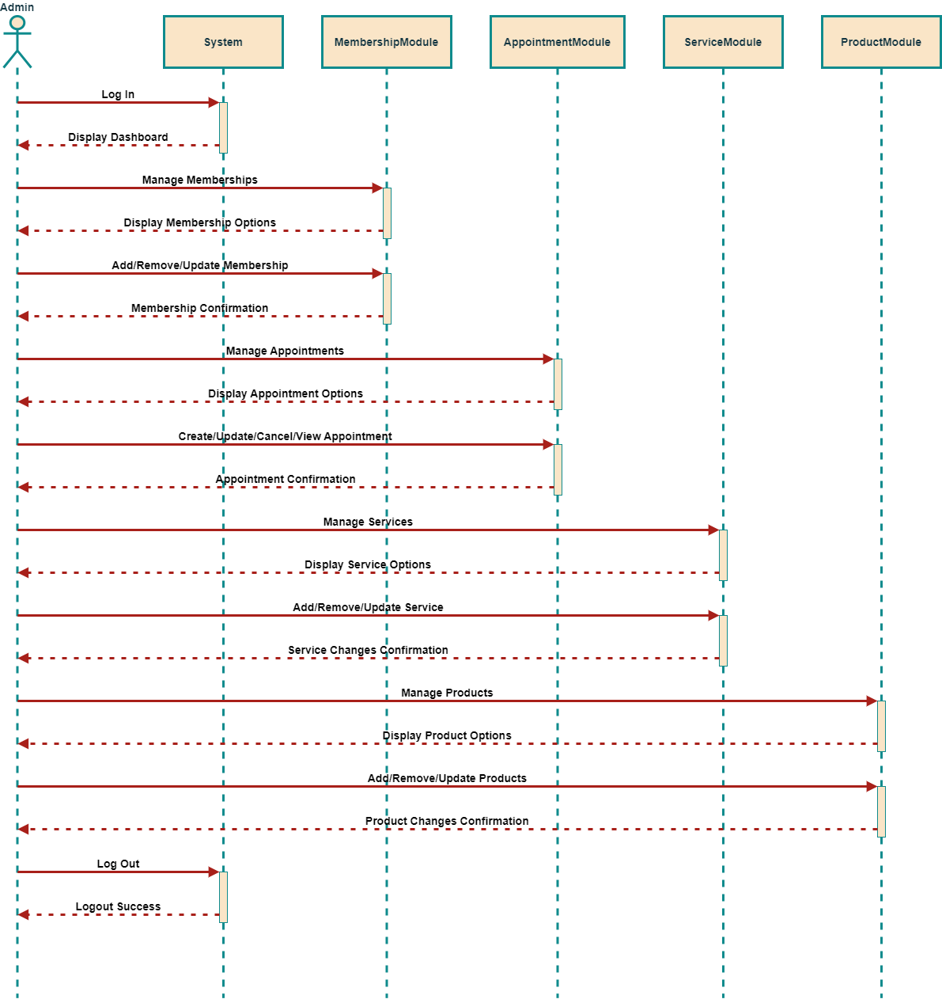

# UserSEQUENCE Diagram

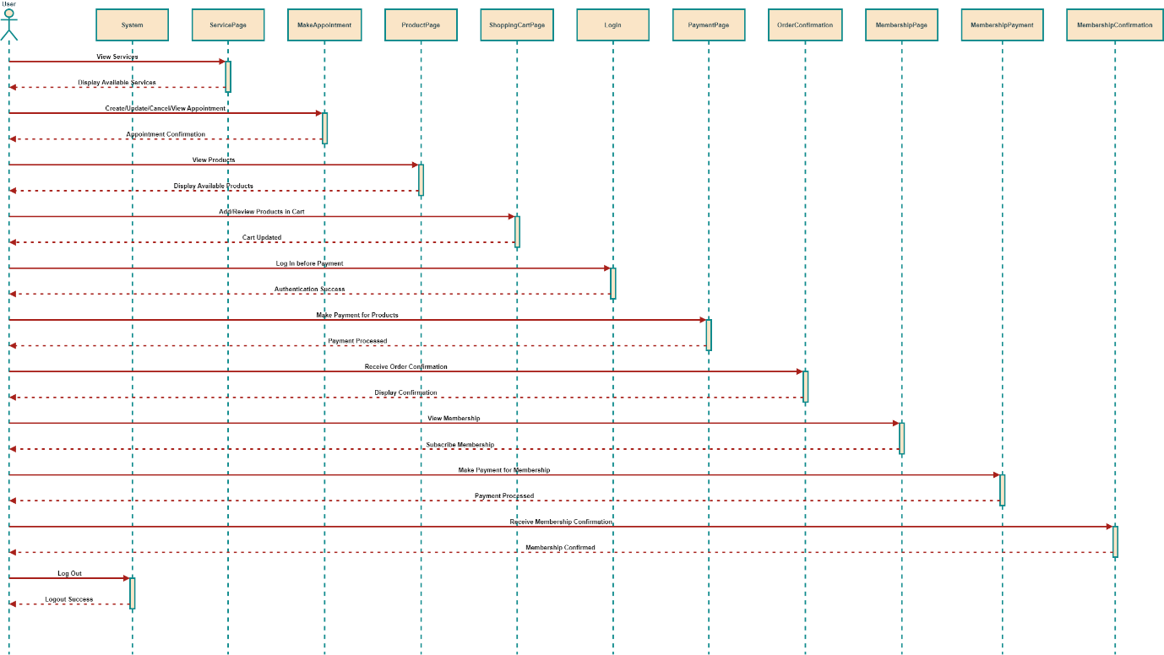

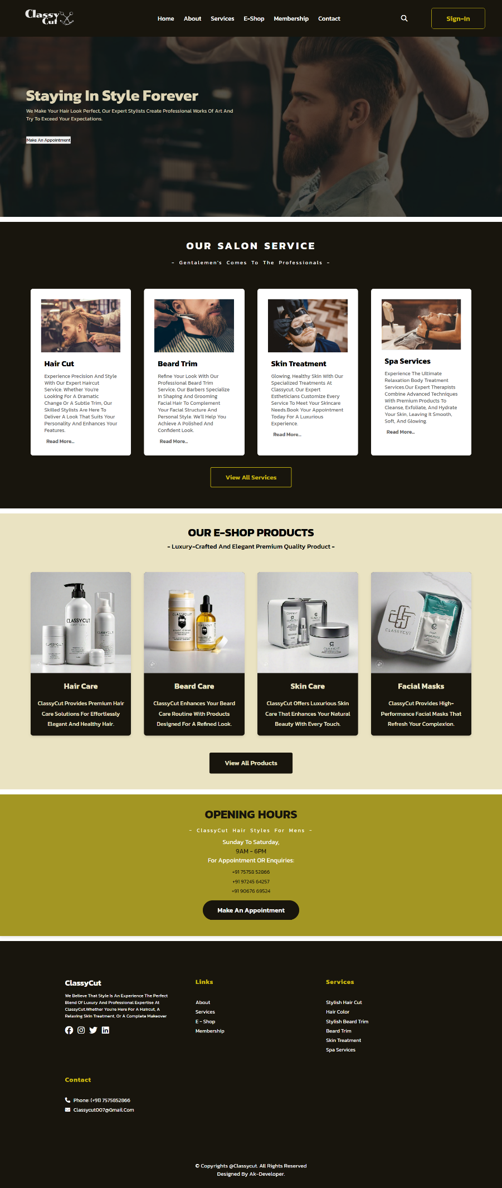

­­

# 21. Future Scope

The future scope of the Men's Hair Salon Management System includes adding the following features:  
  
- Mobile app integration for customers to book appointments on the go.  
- Online payment gateway integration for easier transactions.  
- Automated SMS or email reminders to reduce no-shows and confirm bookings.  
- Advanced analytics to track customer preferences and offer personalized services.

# 22. TESTING

**What is testing?**

Testing is the process of evaluating and verifying that a software product or application. does what it is supposed to do.

**Types of testing:-**

¬ Manual testing

¬ Automation testing

**Manual testing :**

**White Box Testing:-**

• It is Software testing technique that involves testing the internal structure and workings of a software application.

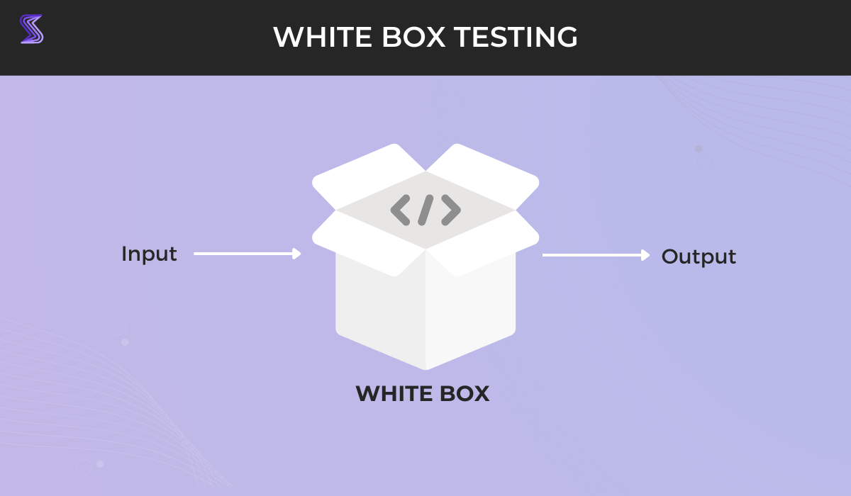

**Black Box Testing:-**

• A form of testing that is performed with no knowledge of a system’s internals.

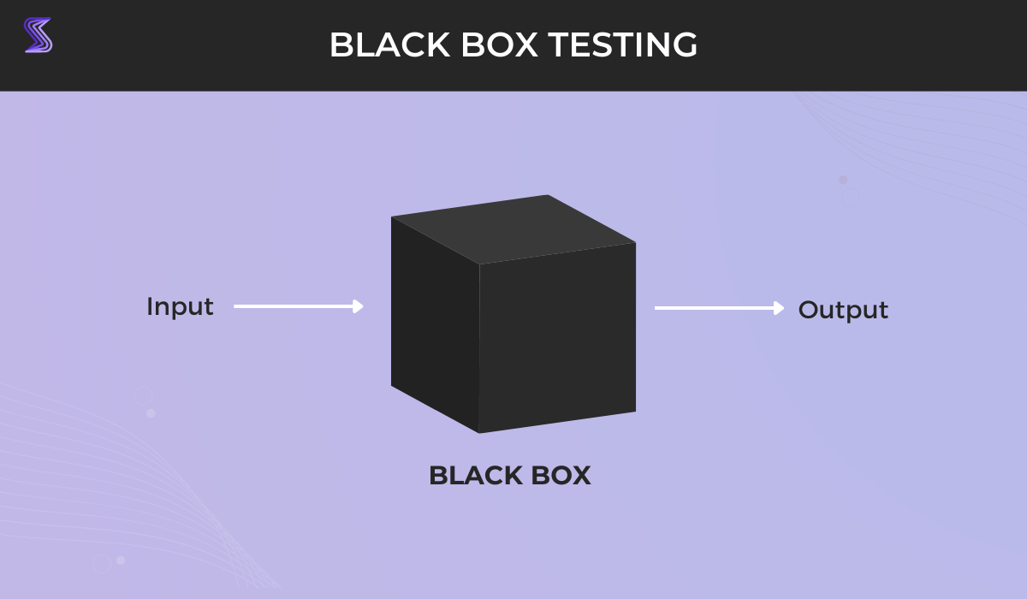

**Gray Box Testing:-**

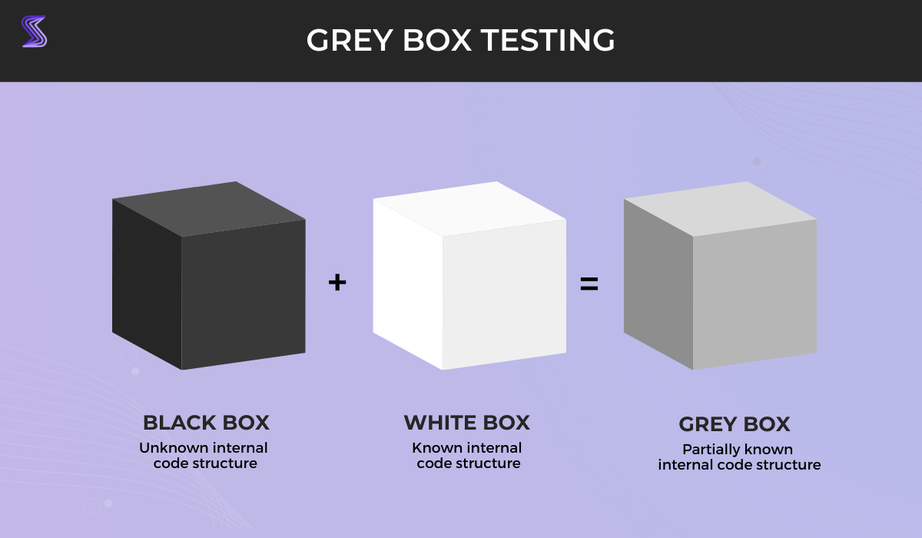• In Gray box testing, the tester is not required to design test case.

# 23. TESTCASE

|  |  |  |  |  |
| --- | --- | --- | --- | --- |
| TC No. | Test Case Name | Pre  Requisite | Post Requisite | Expected  Result |
| 1 | Verify Admin Login with Username and Password | Username and password need to match for login. | Admin should be kept logged in until logout. | System displays Admin home page. |
| 2 | Verify User Login with Username and Password | User should be registered with valid username & password before login. | Admin should be kept logged in until logout. | System displays User home page. |
| 3 | Verify User Login with Invalid Username and Password | User not registered with valid username & password before login. | Redirect to login page. | Display error message: login failed. |
| 4 | Forgot Password | User should be registered with valid username & password before clicking on forgot password. | Redirect to login page. | User will set new password after verifying email and successful password change. |

# 24. References

- www.php.net  
- www.mysql.com  
- www.w3schools.com  
- www.stackoverflow.com